# Najaf Mall Requirements

This document describes the requirements for the **first phase** only of the Najaf Mall system.

## User Types

1. Customer
2. Seller
3. Administrator

## Apps and Sub Systems

In the first phase, there are 3 systems that the users will interact with:

1. Customer App
2. Seller App
3. Firebase (to be used by Administrator)

In the first phase, the two apps are **Android based only**. Also, initially Administrators will only use Firebase to interact with the system. Future phases will have a separate application for the Administrator.

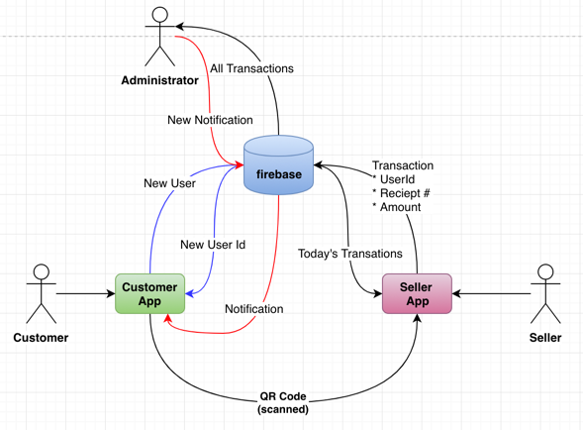

## Use Cases

1. As a Customer, I can register myself in the Customer App
2. As a Customer, I can display my own QR code to the Seller
3. As a Seller, I can login/logout to the Seller App
4. As a Seller, I can enter a transaction by reading customer’s QR code
5. As a Seller, I can view all transactions that I entered today
6. As an administrator, I can view all transactions
7. As an administrator, I can push a notification to all customers using the Customer App

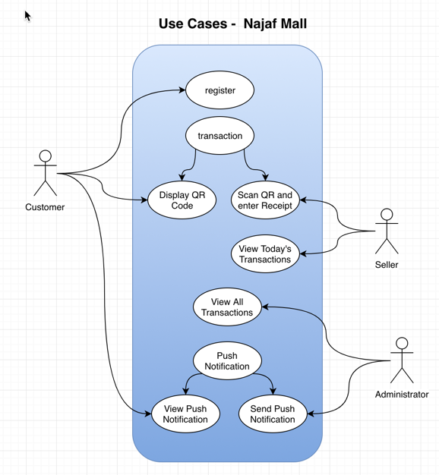

### As a Customer, I can register myself in the Customer App